Name: Lokesh M K
Reg no: 192321160
Course code: CSA1616
Course Name: Data Warehousing and Data Mining

Experiment-12
AIM: To show the Covariance and correlation Children of three ages are asked to indicate their preference for three photographs of adults.
Algorithm:
1. Take the values of B and C.
2. Find the mean of B and the mean of C.
3. Subtract the mean from each value (get deviations).
4. Multiply the deviations of B and C for each pair.
5. Add all products.
6. Divide by n – 1 → this gives the sample covariance.
Code
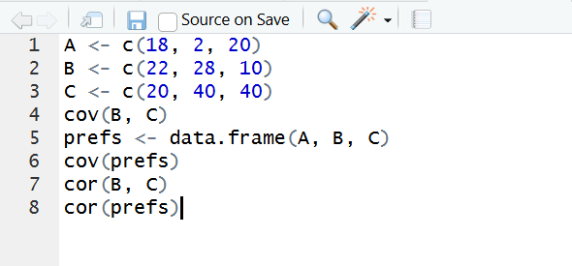

Output
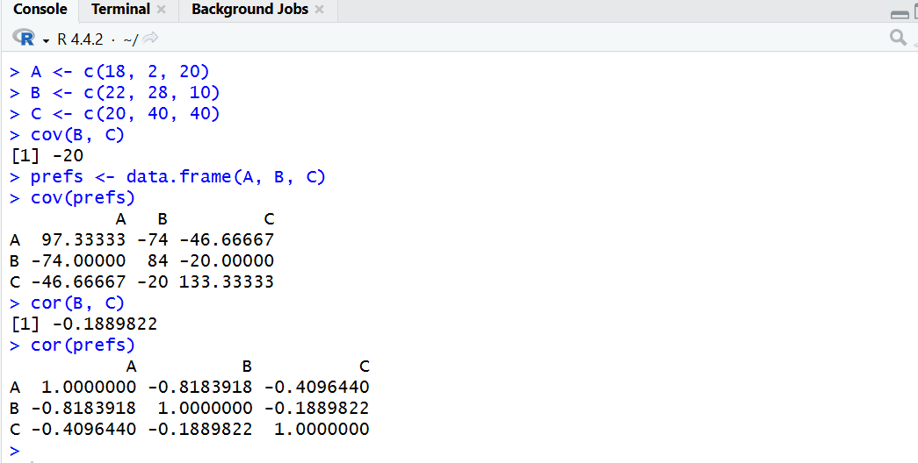
Result: It is executed successfully.

Experiment-13
AIM: To divide the given price data into equal-frequency bins, apply data smoothing (bin means & bin boundaries), and draw a histogram using R.
Algorithm:
1. Equal-frequency partitioning
- Read the sorted data.
- Decide number of bins = 3.
- Count total items.
- Compute items per bin = total / 3.
- Divide the data into 3 bins with equal number of values
2.Data smoothing
A. Bin Mean
- For each bin, calculate the mean.
- Replace every value in the bin with the bin’s mean.
B. Bin Boundary
- For each bin, find the minimum and maximum value.
- Replace each value with the nearest boundary (min or max)
3.Histogram
- Read the price data.
- Use the hist() function to plot a histogram.
- Label the axes.
Code
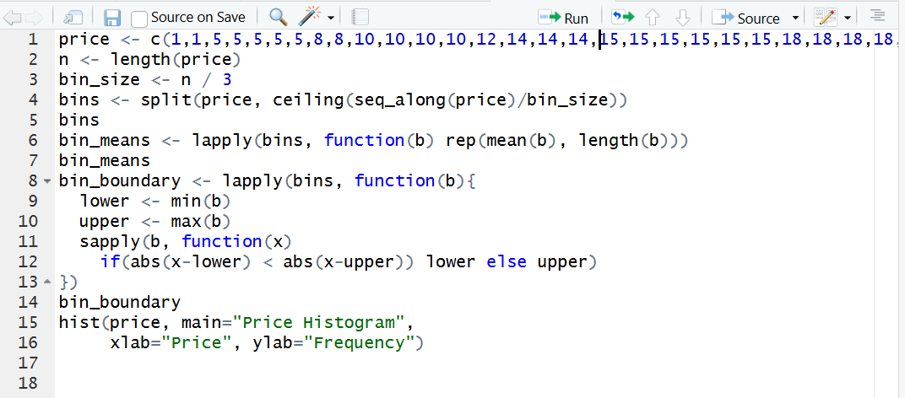
Output
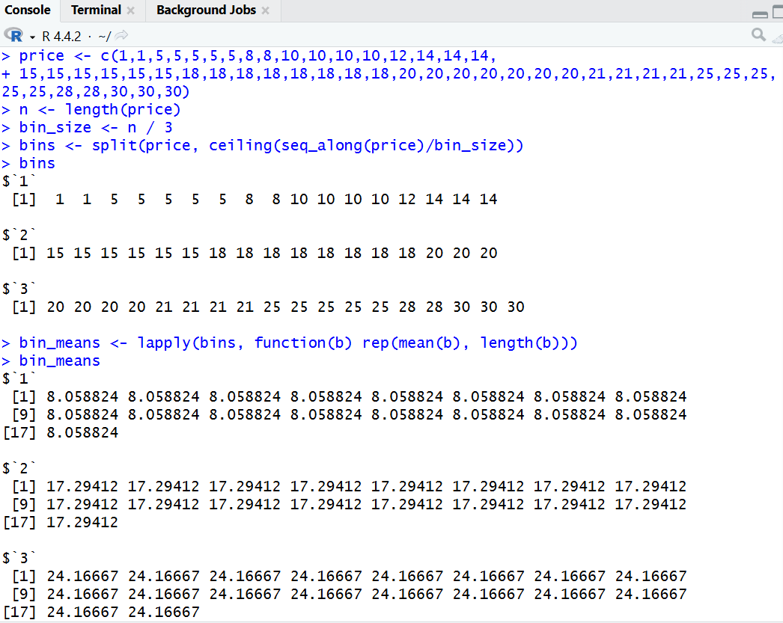

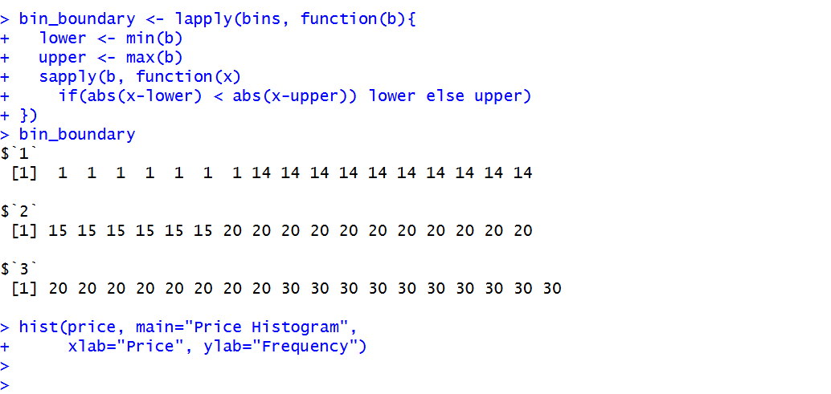
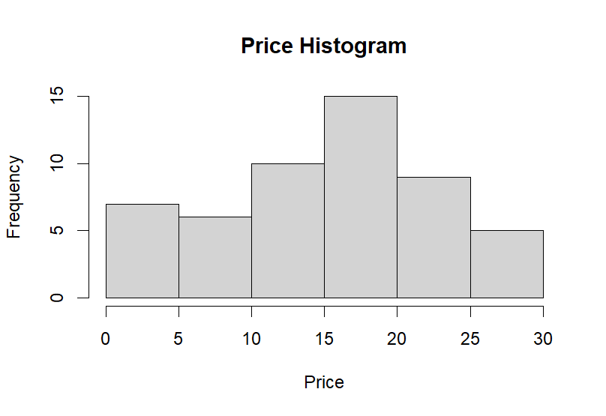
Result: It is executed successfully.

